**COMP329 Individual Log**

**Name: Yuan Gao ID: 201218960**

20th. Nov – 21st. Nov: Read and understand the requirements of the assignment 2.

21st.Nov: Start to design the structure of the program.

21st.Nov – 22nd.Nov: List all potential classes used in the program.

23rd.Nov – 25th.Nov: Start to do some planning of the localization algorithm. The following figure shows the initial planning of the algorithm:

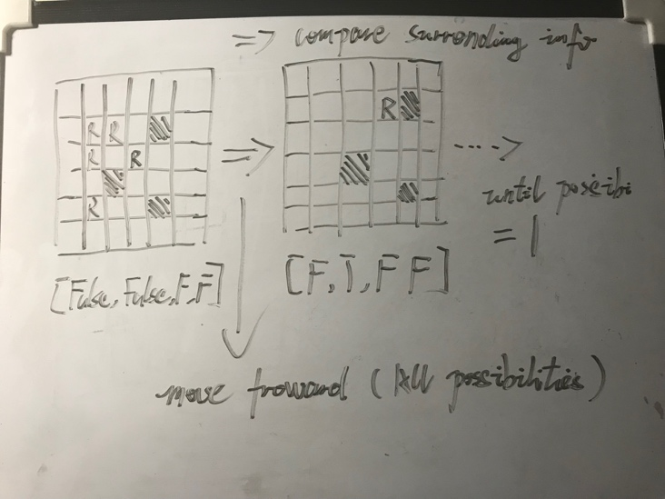

Figure 1: Initial planning of the localization algorithm

26th.Nov – 27th.Nov: Did doctor and scout code. Has some problem but its working.

28th.Nov – 30 th.Nov: Implement the localization algorithm, the display of the graphic interface and a robot simulator. Test the localization algorithm and its full worked on the simulator.

1st.Dec – 2nd.Dec: Planned and implemented an initial path planning algorithm using A* greedy method. Tried the path planning algorithm with the simulator, found a issue that the algorithm in some specific situation is not return the optimal path.

3rd.Dec – 5th.Dec: Did a new path planning algorithm with tree searching. Implement a multi branched searching tree and using A* as basic to plan the path. Analysed the complexity of this algorithm and found that the time complexity is at most O(5!). Finally got the conclusion that the algorithm is applicable for this assignment.

6th.Dec: Integrated code with Geri’s client-server framework. Did some modification of her code in order to make suitable for this assignment.

7th.Dec: Modified the simulator. Add the client-server function within it. Then test the PC side code, its fully worked.

8th.Dec: Found the bug of the json code and reconstructed it.

9th.Dec: Did the robot side code without calibration. Using tape to correct the odometry in order to make the robot movement suitable for different arenas.

10th.Dec: Tested the code with robot No.4. It’s working properly.

11st.Dec: Did some modifications of the previous calibration code and integrated it with assignment 2 code.

12nd.Dec – 13rd.Dec: Test and adjust parameters.

14th.Dec: Did a new algorithm which support the robot calculate the victim position based on the direction vectors. During the localization process, if the robot detected a victim then the robot could record moving path after that victim. After localization process is done, the robot could use these path and direction vectors to calculate the position of the victims that met during the localization. This will help to reduce the total steps of the mission.

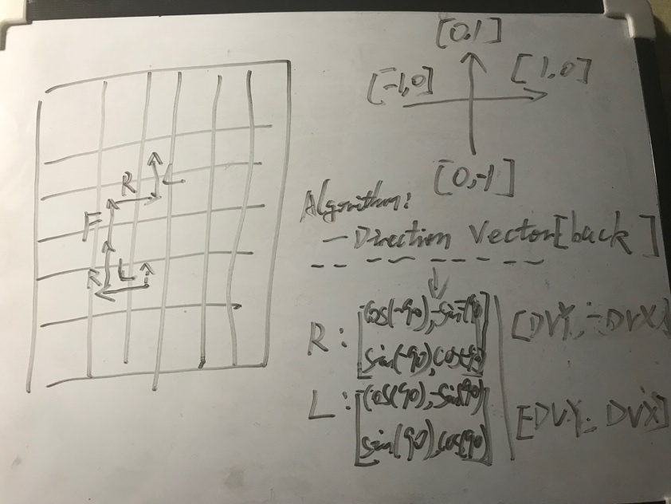

Figure 2: Planning of the calculation algorithm based on the direction vector and rotation matrix

15th.Dec: Found a bug about the new algorithm. Reconstruct the new algorithm and fixed the bug.

18th.Dec: Preparation of demonstration. Test different arenas and record parameters.

19th.Dec: Test and did the demonstration. All 3 arenas demoed and all passed.